Chapter 17
Output and the Exchange Rate
in the Short Run

■ Chapter Organization
Determinants of Aggregate Demand in an Open Economy.
Determinants of Consumption Demand.
Determinants of the Current Account.
How Real Exchange Rate Changes Affect the Current Account.
How Disposable Income Changes Affect the Current Account.
The Equation of Aggregate Demand.
The Real Exchange Rate and Aggregate Demand.
Real Income and Aggregate Demand.
How Output Is Determined in the Short Run.
Output Market Equilibrium in the Short Run: The DD Schedule.
Output, the Exchange Rate, and Output Market Equilibrium.
Deriving the DD Schedule.
Factors that Shift the DD Schedule.
Asset Market Equilibrium in the Short Run: The AA Schedule.
Output, the Exchange Rate, and Asset Market Equilibrium.
Deriving the AA Schedule.
Factors that Shift the AA Schedule.
Short-Run Equilibrium for an Open Economy: Putting the DD and AA Schedules Together.
Temporary Changes in Monetary and Fiscal Policy.
Monetary Policy.
Fiscal Policy.
Policies to Maintain Full Employment.
Inflation Bias and Other Problems of Policy Formulation.
Permanent Shifts in Monetary and Fiscal Policy.
A Permanent Increase in the Money Supply.
Adjustment to a Permanent Increase in the Money Supply.
A Permanent Fiscal Expansion.
Macroeconomic Policies and the Current Account.
Gradual Trade Flow Adjustment and Current Account Dynamics.
The J-Curve.
Exchange Rate Pass-Through and Inflation.
Global Value Chains and Exchange Rate Effects on Export and Import Prices
The Current Account, Wealth, and Exchange Rate Dynamics.
Box: Understanding Pass-Through to Import and Export Prices.
The Liquidity Trap.
Case Study: How Big Is the Government Spending Multiplier?
SUMMARY
APPENDIX 1 TO CHAPTER 17: Intertemporal Trade and Consumption Demand
APPENDIX 2 TO CHAPTER 17: The Marshall-Lerner Condition and Empirical Estimates of Trade Elasticities
APPENDIX 3 TO CHAPTER 17: The IS-LM Model and the DD-AA Model

n Chapter Overview
This chapter integrates the previous analysis of exchange rate determination with a model of short-run output determination in an open economy. The model presented is similar in spirit to the classic Mundell-Fleming model, but the discussion goes beyond the standard presentation in its contrast of the effects of temporary versus permanent policies. The distinction between temporary and permanent policies allows for an analysis of dynamic paths of adjustment rather than just comparative statics. This dynamic analysis brings in the possibility of a J-curve response of the current account to currency depreciation. The chapter concludes with a discussion of exchange rate pass-through, that is, the response of import prices to exchange rate movements.
The chapter begins with the development of an open-economy fixed-price model. An aggregate demand function is derived using a Keynesian cross diagram in which the real exchange rate serves as a shift parameter. A nominal currency depreciation increases output by stimulating exports and reducing imports, given foreign and domestic prices, fiscal policy, and investment levels. This yields a positively sloped output-market equilibrium (DD) schedule in exchange rate output space. A negatively sloped asset-market equilibrium (AA) schedule completes the model. The derivation of this schedule follows from the analysis of previous chapters. For students who have already taken intermediate macroeconomics, you may want to point out that the intuition behind the slope of the AA curve is identical to that of the LM curve, with the additional relationship of interest parity providing the link between the closed-economy LM curve and the open-economy AA curve. As with the LM curve, higher income increases money demand and raises the home-currency interest rate (given real balances). In an open economy, higher interest rates require currency appreciation to satisfy interest parity (for a given future expected exchange rate).
The effects of temporary policies, as well as the short-run and long-run effects of permanent policies, can be studied in the context of the DD-AA model if we identify the expected future exchange rate with the long-run exchange rate examined in Chapters 15 (4) and 16 (5). In line with this interpretation, temporary policies are defined to be those that leave the expected exchange rate unchanged, while permanent policies are those that move the expected exchange rate to its new long-run level. As in the analysis in earlier chapters, in the long run, prices change to clear markets (if necessary). Although the assumptions concerning the expectational effects of temporary and permanent policies are unrealistic as an exact description of an economy, they are pedagogically useful because they allow students to grasp how differing market expectations about the duration of policies can alter their qualitative effects. Students may find the distinction between temporary and permanent, on the one hand, and between short run and long run on the other, a bit confusing at first. It is probably worthwhile to spend a few minutes discussing this topic.
Both temporary and permanent increases in money supply expand output in the short run through exchange rate depreciation. The long-run analysis of a permanent monetary change once again shows how the well-known Dornbusch overshooting result can occur. Temporary expansionary fiscal policy raises output in the short run and causes the exchange rate to appreciate. Permanent fiscal expansion, however, has no effect on output even in the short run. The reason for this is that, given the assumptions of the model, the currency appreciation in response to permanent fiscal expansion completely “crowds out” exports. This is a consequence of the effect of a permanent fiscal expansion on the expected long-run exchange rate, which shifts the asset-market equilibrium curve inward. This model can be used to explain the consequences of U.S. fiscal and monetary policies between 1979 and 1984. The model explains the recession of 1982 and the appreciation of the dollar as a result of tight monetary and loose fiscal policy.
The chapter concludes with some discussion of real-world modifications of the basic model. Recent experience casts doubt on a tight, unvarying relationship between movements in the nominal exchange rate and shifts in competitiveness and thus between nominal exchange rate movements and movements in the trade balance as depicted in the DD-AA model. Exchange rate pass-through is less than complete and thus nominal exchange rate movements are not translated one-for-one into changes in the real exchange rate. Furthermore, the degree of exchange rate pass through will depend on the currency that exports are invoiced in as well as whether an exchange rate change was caused by a change in output demand (less pass-through) or a change in asset demand (more pass-through). Also, the current account may worsen immediately after currency depreciation. This J-curve effect occurs because of time lags in deliveries and because of low elasticities of demand in the short run as compared to the long run. This is expanded upon in Appendix 2, which discusses the Marshall-Lerner conditions relating import and export elasticities to how an exchange rate change affects the current account.
The chapter contains a discussion of the way in which the analysis of the model would be affected by the inclusion of incomplete exchange rate pass-through and time-varying elasticities. There is also a discussion of how global value chains in which countries both import and export intermediate goods. These backward and forward linkages from inputs to outputs can dampen the impact of exchange rate changes on final goods prices.
A discussion of how the current account balance can affect the exchange rate is also illuminating: A country running a persistent current account deficit will experience a loss in net foreign wealth, which in turn may depreciate the currency given home biases in consumption. This observation is matched with U.S. data to illustrate that fiscal expansions in the United States that initially lead to currency appreciations and current account deficits will, over time, lead to depreciations in the dollar. The chapter concludes with the efficacy of monetary policy in a liquidity trap. When nominal interest rates are at zero (as they effectively were in the United States in 2010), any attempt to stimulate the economy through monetary expansion will be ineffective given that interest rates cannot fall below zero. A modification of the DD-AA model shows that for a country in a liquidity trap, a section of the AA curve is perfectly elastic. In fact, monetary policy can only affect output by changing the expected exchange rate. This may explain the unconventional monetary policies recently taken by the Federal Reserve such as the purchase of long-term government bonds.

n Answers to Textbook Problems

1. A decline in investment demand decreases the level of aggregate demand for any level of the exchange rate. Thus, a decline in investment demand causes the DD curve to shift to the left.

2. A tariff is a tax on the consumption of imports. The demand for domestic goods, and thus the level of aggregate demand, will be higher for any level of the exchange rate. This is depicted in Figure 17(6)-1 (below) as a rightward shift in the output market schedule from DD to D′D′. If the tariff is temporary, this is the only effect, and output will rise even though the exchange rate appreciates as the economy moves from points 0 to 1. If the tariff is permanent, however, the long-run expected exchange rate appreciates, so the asset market schedule shifts to A′A′. The appreciation of the currency is sharper in this case. If output is initially at full employment, then there is no change in output due to a permanent tariff.

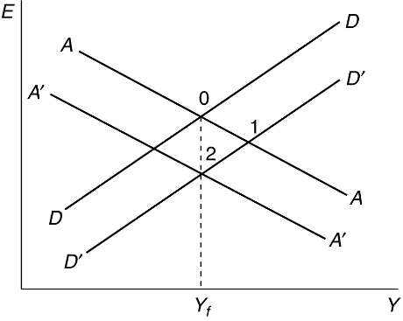

Figure 17-1

3. A temporary fiscal policy shift affects employment and output, even if the government maintains a balanced budget. An intuitive explanation for this relies upon the different propensities to consume of the government and of taxpayers. If the government spends $1 more and finances this spending by taxing the public $1 more, aggregate demand will have risen because the government spends the entire $1, while the public reduces its spending by less than $1 (choosing to reduce its saving as well as its consumption). The ultimate effect on aggregate demand is even larger than this first round difference between government and public spending propensities, since the first round generates subsequent spending. (Of course, currency appreciation still prevents permanent fiscal shifts from affecting output in our model.)

4. A permanent fall in private aggregate demand causes the DD curve to shift inward and to the left and, because the expected future exchange rate depreciates, the AA curve shifts outward and to the right. These two shifts result in no effect on output, however, for the same reason that a permanent fiscal expansion has no effect on output. The net effect is a depreciation in the nominal exchange rate and, because prices will not change, a corresponding real exchange rate depreciation. A macroeconomic policy response to this event would not be warranted.

5. Figure 17-2 (below) can be used to show that any permanent fiscal expansion worsens the current account. In this diagram, the schedule XX represents combinations of the exchange rate and income for which the current account is in balance. Points above and to the left of XX represent current account surplus, and points below and to the right represent current account deficit. A permanent fiscal expansion shifts the DD curve to D′D′ and, because of the effect on the long-run exchange rate, the AA curve shifts to A′A′. The equilibrium point moves from 0, where the current account is in balance, to 1, where there is a current account deficit. If, instead, there was a temporary fiscal expansion of the same size, the AA curve would not shift and the new equilibrium would be at point 2 where there is a current account deficit, although it is smaller than the current account deficit at point 1. Thus, a temporary increase in government spending causes the current account to decline by less than a permanent increase because there is no change in expectations with a temporary shock and thus the AA curve does not move.

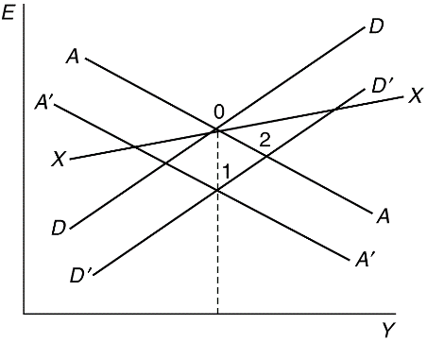Figure 17-2

6. A temporary tax cut shifts the DD curve to the right and, in the absence of monetization, has no effect on the AA curve. In Figure 17-3, this is depicted as a shift in the DD curve to D′D′, with the equilibrium moving from points 0 to 1. If the deficit is financed by future monetization, the resulting expected long-run nominal depreciation of the currency causes the AA curve to shift to the right to A′A′, which gives us the equilibrium point 2. The net effect on the exchange rate is ambiguous, but output certainly increases more than in the case of a pure fiscal shift.

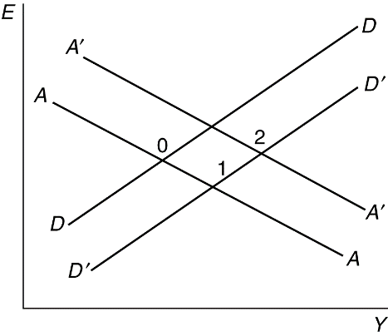

Figure 17-3

7. A currency depreciation accompanied by a deterioration in the current account balance could be caused by factors other than a J-curve. For example, a fall in foreign demand for domestic products worsens the current account and also lowers aggregate demand, depreciating the currency. In terms of Figure 17-4, DD and XX undergo equal vertical shifts, to D′D′ and X′X′, respectively, resulting in a current account deficit as the equilibrium moves from points 0 to 1. To detect a J-curve, one might check whether the prices of imports in terms of domestic goods rise when the currency is depreciating, offsetting a decline in import volume and a rise in export volume.

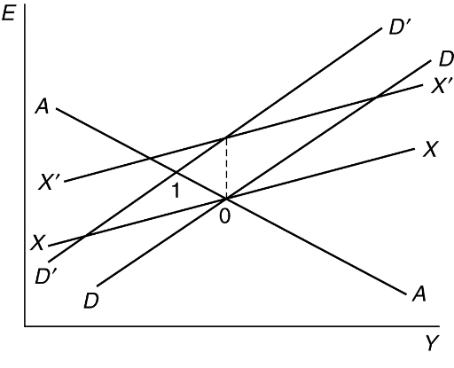

Figure 17-4

8. The expansionary money supply announcement causes a depreciation in the expected long-run exchange rate and shifts the AA curve to the right. This leads to an immediate increase in output and a currency depreciation. The effects of the anticipated policy action thus precede the policy’s actual implementation.

9. The DD curve might be negatively sloped in the very short run if there is a J-curve, though the absolute value of its slope would probably exceed that of AA. This is depicted in Figure 17-5. The effects of a temporary fiscal expansion, depicted as a shift in the output market curve to D′D′, would not be altered because it would still expand output and appreciate the currency in this case (the equilibrium points move from 0 to 1).

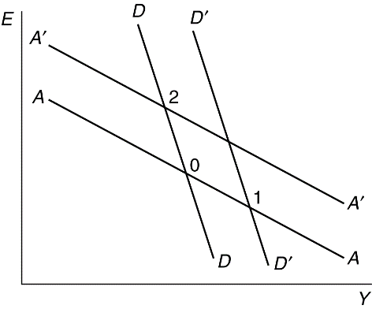

Figure 17-5

Monetary expansion, however, while depreciating the currency, would reduce output in the very short run. This is shown by a shift in the AA curve to A′A′ and a movement in the equilibrium point from 0 to 2. Only after some time would the expansionary effect of monetary policy take hold (assuming the domestic price level did not react too quickly).

10. The derivation of the Marshall-Lerner condition uses the assumption of a balanced current account to substitute EX for (q × EX*). We cannot make this substitution when the current account is not initially zero. Instead, we define the variable z = (q × EX*)/EX. This variable is the ratio of imports to exports, denominated in common units. When there is a current account surplus, z will be less than 1, and when there is a current account deficit, z will exceed 1. It is possible to take total derivatives of each side of the equation CA = EX − q EX* and derive a general Marshall-Lerner condition as n + z n* > z, where n and n* are as defined in Appendix 2. The balanced current account (z = 1) Marshall-Lerner condition is a special case of this general condition. A depreciation is less likely to improve the current account the larger its initial deficit when n* is less than 1. Conversely, a depreciation is more likely to cause an improvement in the current account the larger its initial surplus, again for values of n* less than 1.

11. If imports constitute part of the CPI, then a fall in import prices due to an appreciation of the currency will cause the overall price level to decline. The fall in the price level raises the real money supply. As shown in Figure 17-6, the permanent fiscal expansion will shift the output market curve from DD to D′D′ and is matched by an inward shift of the asset market equilibrium curve. If import prices are not in the CPI and the currency appreciation does not affect the price level, the asset market curve shifts to A″A″, and there is no effect on output, even in the short run. If, however, the overall price level falls due to the appreciation, the shift in the asset market curve is smaller, to A′A′, and the initial equilibrium point, point 1, has higher output than the original equilibrium at point 0. Over time, prices rise when output exceeds its long-run level, causing a shift in the asset market equilibrium curve from A′A′ to A″A″, which returns output to its long-run level.

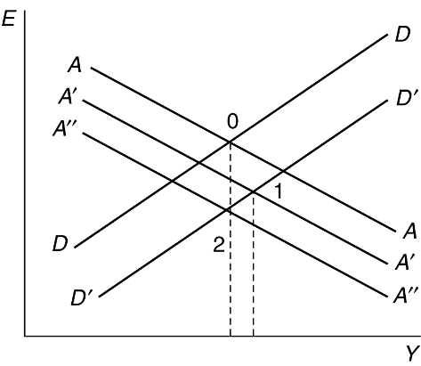

Figure 17-6

12. An increase in the risk premium shifts the asset market curve out and to the right, all else being equal. A permanent increase in government spending shifts the asset market curve in and to the right because it causes the expected future exchange rate to appreciate. A permanent rise in government spending also causes the goods market curve to shift down and to the right because it raises aggregate demand. In the case where there is no risk premium, the new intersection of the DD and AA curves after a permanent increase in government spending is at the full-employment level of output because this is the only level consistent with no change in the long-run price level. In the case discussed in this question, however, the nominal interest rate rises with the increase in the risk premium. Therefore, output must also be higher than the original level of full-employment output; as compared to the case in the text, the AA curve does not shift by as much, so output rises.

13. Suppose output is initially at full employment. A permanent change in fiscal policy will cause both the AA and DD curves to shift such that there is no effect on output. Now consider the case where the economy is not initially at full employment. A permanent change in fiscal policy shifts the AA curve because of its effect on the long-run exchange rate and shifts the DD curve because of its effect on expenditures. There is no reason, however, for output to remain constant in this case because its initial value is not equal to its long-run level, and thus an argument like the one in the text that shows the neutrality of permanent fiscal policy on output does not carry through. In fact, we might expect that an economy that begins in a recession (below Y^{f}) would be stimulated back toward Y^{f} by a positive permanent fiscal shock. If Y does rise permanently, we would expect a permanent drop in the price level (because M is constant). This fall in P in the long run would move AA and DD both out. We could also consider the fact that in the case where we begin at full employment and there is no impact on Y, AA was shifting back due to the real appreciation necessitated by the increase in demand for home products (as a result of the increase in G). If there is a permanent increase in Y, there has also been a relative supply increase that can offset the relative demand increase and weaken the need for a real appreciation. Because of this, AA would shift back by less. We do not know the exact effect without knowing how far the lines originally move (the size of the shock), but we do know that without the restriction that Y is unchanged in the long run, the argument in the text collapses, and we can have both short-run and long-run effects on Y.

14. We are given that the central bank in the economy can keep both interest rates and exchange rates fixed. Thus, we need to only consider the goods side of the economy. The goods market equilibrium is Y = (1 − s)Y + I + G + aE − mY. Collecting terms and solving for Y yields:

Y = (I + G + aE)/(s + m)

Thus, a 1 unit increase in government spending will cause output to increase by 1/(s + m). Recall that s is the marginal propensity to save and m is the marginal propensity to import. As both of these marginal propensities increase, the multiplier effect of government spending will decrease. This makes intuitive sense as the impact of government spending will be diluted if some of that spending is saved (s) and if some of that spending leaves the country through imports (m).

15. The text shows output cannot rise following a permanent fiscal expansion if output is initially at its long-run level. Using a similar argument, we can show that output cannot fall from its initial long-run level following a permanent fiscal expansion. A permanent fiscal expansion cannot have an effect on the long-run price level because there is no effect on the money supply or the long-run values of the domestic interest rate and output. When output is initially at its long-run level, R equals R*, Y equals Y^{f}, and real balances are unchanged in the short run. If output did fall, there would be excess money supply and the domestic interest rate would have to fall, but this would imply an expected appreciation of the currency because the interest differential (R − R*) would then be negative. This, however, could only occur if the currency appreciates in real terms as output rises and the economy returns to long-run equilibrium. This appreciation, however, would cause further unemployment, and output would not rise and return back to Y^{f}. As with the example in the text, this contradiction is only resolved if output remains at Y^{f}.

16. It is difficult to see how government spending can rise permanently without increasing taxes or how taxes can be cut permanently without cutting spending. Thus, a truly permanent fiscal expansion is difficult to envision. The one possible scenario is if the government realized it was on a path to permanent surpluses and it could cut taxes without risking long-run imbalances. Because rational agents are aware the government has a long-run budget constraint, they may assume that any fiscal policy is actually temporary. This would mean that a “permanent” shock would look just like a temporary one. This is quite similar to the discussion of problem 14 in this chapter.

17. High inflation economies should have higher pass-through as price setters are used to making adjustments faster (menu costs fall over time as people learn how to change prices faster). Thus, a depreciation in a high-inflation economy may see a rapid response of changing prices, but firms in a low-inflation environment may be loathe to increase prices for fear of losing business, given that their customers are not accustomed to price changes. In addition, a depreciation by a high-inflation economy may be more likely to have been caused by an increase in the money supply, which would lead to price increases on its own anyway, so the pass-through would appear higher.

18. A “buy American” provision would have resulted in a larger rightward shift in the DD curve than an unconstrained increase in government spending because there will be a greater demand for U.S. output than if some imported goods could have been purchased with the stimulus funds. However, if this increase in government spending is permanent, then the net effect on output would be the same regardless of the provision. A permanent increase in government spending will appreciate the expected future value of the dollar, leading to a leftward shift in the AA curve. The larger the fiscal stimulus (rightward shift in DD), the larger the offsetting leftward shift in the AA curve. Thus, the “buy American” provision would not have had any larger effect on output than unconstrained fiscal policy if the increase in government spending was permanent. If the increase in spending was temporary, a “buy American” provision could have had a larger effect in the short run, but would have led to a larger increase in prices in the long run, leaving the net long-run effect the same.

19. We are given that the economy starts out at full employment with R = R*. As such, we know that 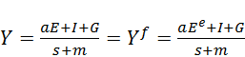. An increase in government spending will not affect the money supply, the long run value of the domestic interest rate, or full employment output. Thus, it will have no impact on the long run price level. We can therefore conclude that an increase in government spending cannot affect output. If it did, then because the real money supply remains unchanged, any increase in output would push the domestic interest rate above the foreign interest rate to keep the money market in equilibrium: 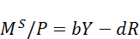. However, because of interest rate parity, if the domestic interest rate R were to increase, then it must be the case that the domestic currency is expected to depreciate. However, this cannot be. When output rises above full employment, there is excess demand. If the currency were to depreciate, then this would only exacerbate this excess demand. As such, it is impossible for an increase in government spending to increase output above full employment.

Rather, the increase in government spending will cause the expected exchange rate to fall (expected appreciation of the domestic currency), which in turn must cause the current exchange rate to fall since R=R*. Looking at the expression for output we derived as 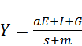, any increase in G will be offset by a proportionate decrease in aE, leaving output unchanged. The larger the parameter a, the smaller the appreciation of the domestic currency to an increase in government spending.

20. Start with the money market condition 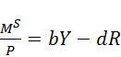 and plug in the approximation for interest rate parity 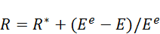. With some manipulation, we can solve for the current exchange rate as 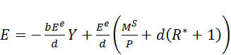. Plug this into the goods market equilibrium and then solving for Y will yield 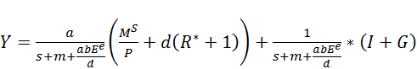. The government spending multiplier is thus given by 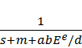, which is similar to what we found in problem 14, with the exception of the term 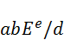. Looking at this expression, we see that the government spending multiplier is decreasing in a and b, but increasing in d.

This makes intuitive sense. An increase in government spending that causes the exchange rate to fall (currency depreciation) will have a smaller effect on output when output is sensitive to exchange rate changes (larger value for a). The parameter b represents the responsiveness of money demand to changes in output. If more output causes the demand for money to rise faster (higher value for b), then any increase in output resulting from government spending will be dampened by the greater demand for money pushing up interest rates. The parameter d measures the responsiveness of money demand to real interest rates. As interest rates rise, the demand for money will fall at a faster rate with a larger value for d, allowing output to expand more in response to government spending.

